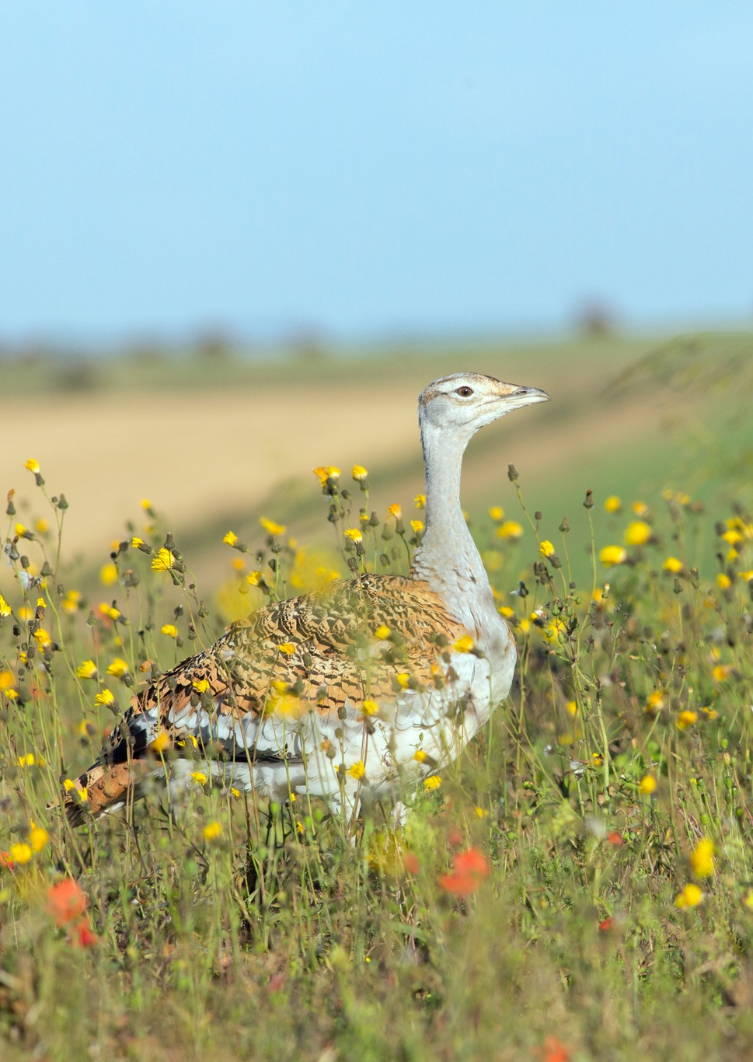

Annual Population and Breeding Report 2024
Tim Edwards, Siobhan Lewis, David Waters.


Annual Population and Breeding Report 2024

Summary

- The current wild population in the UK remains stable at around 50 wild bred or mature birds. Additionally, 27 head started chicks were released in 2024.

- 46 nests were identified this year, which represents the highest total since the start of the project. This figure includes replacement clutches.

- 20 clutches were removed from nests in dangerous or vulnerable locations, with the priority of ensuring the safety of females nesting in silage crops.

- Repeated releases at the original project site have created a high nesting density and this has led to aggression between females and infanticide.

- For a second year running we estimate circa 90% adult survival within last 12 months, with no known fatalities due to silage cutting.

- A minimum of two females were naturally recruited to the population.

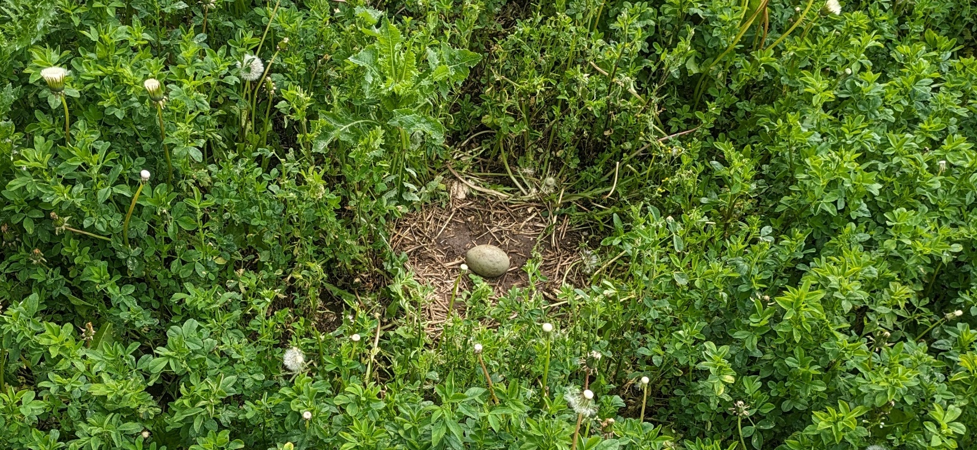
Fig 1: A nest detected by drone in a field of Lucerne, May 2024.
Contents

- Monitoring Methods

- Geospatial Databasing

- 2023/24 Winter Census

- The Lek

- Nesting

- Return to Winter Habitat

- Head Starting

- Conclusion

- Future Conservation

- Thanks and Acknowledgements

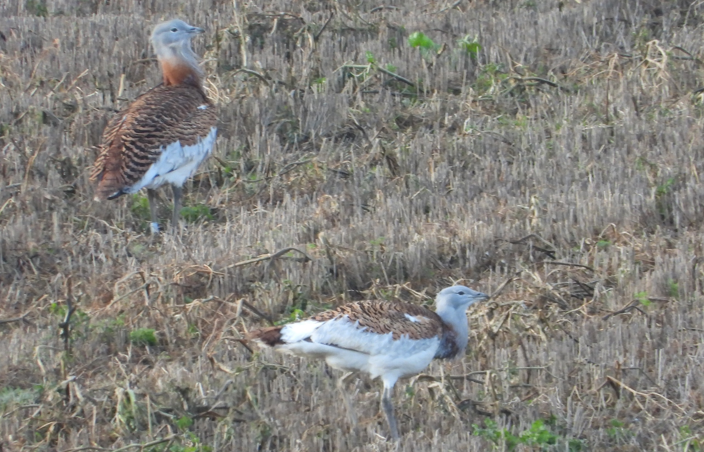
Fig 2: Males on stubble at Compton in January 2024.
Note the leg ring on the top bird, a highly abraded blue ring, indicating a 2018 bird.
Monitoring Methods

Locating nests is an important feature of the monitoring programme. Our primary aim in monitoring has been to detect females nesting within silage fields, in order to prevent casualties from mowing and safeguard future productivity. This year we also decided to recover eggs from threatened nests, which we retrieved under a Natural England licence. As such our monitoring is conducted with a practical aim in mind, as well as improving our understanding of the species. Out of breeding season, our monitoring effort has focused on understanding population trends in order to inform future conservation effort.

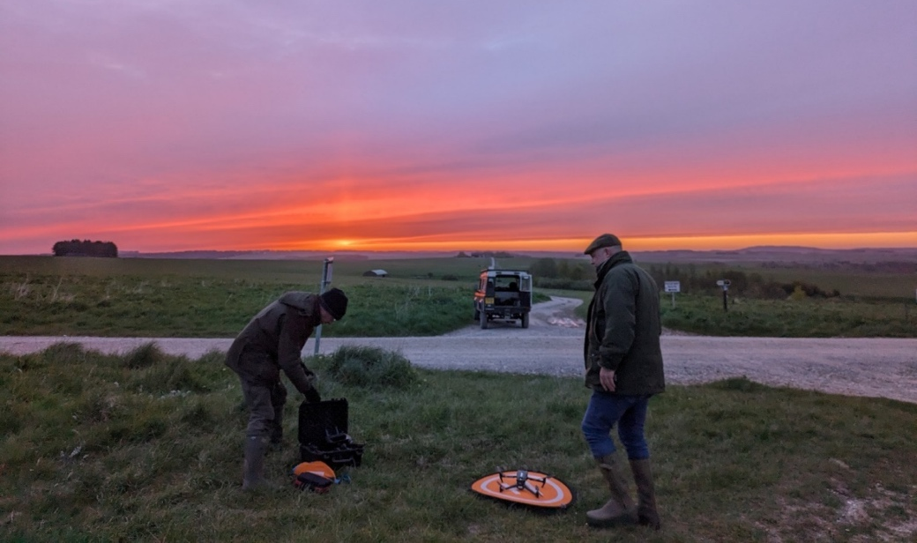
Fig 3: An early morning drone sortie on Sailsbury Plain.
Every such sortie was cleared in advance by the MoD.

2024 marks the second year in which we have fielded a thermal drone, accordingly we are building valuable experience which has enabled us to detect more nests. We have also recruited and trained many more volunteers, allowing us to sustain an intensive program of monitoring for the three month period in which nesting occurs. Whereas the majority of sorties in 2023 were conducted by just two GBG staff, we have this year recruited and trained a further 12 drone team members, who have been generous in supporting us with their time.
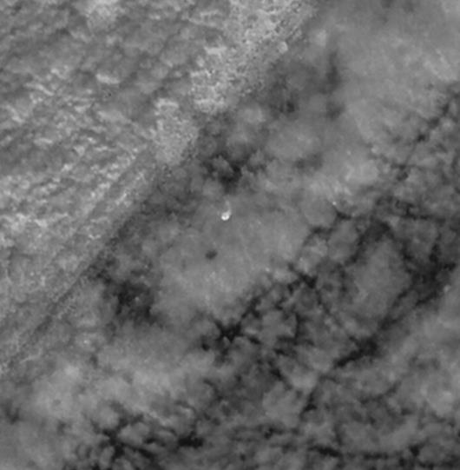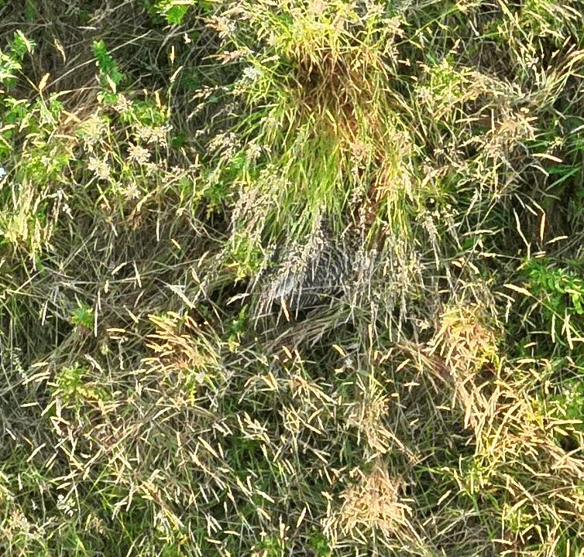
Fig 4: A nesting female concealed in long grass.

Strong relations with local landowners and the Ministry of Defence have been fundamental for the success of our monitoring programme, not just in securing permission to fly over private land, but also in providing us leads to investigate.

The number of nests we have found in 2024 is more than double that of last year. This is partly due to our growing experience in operating the technology, but mainly due to a change in our planning. We have focussed our time on a much more targeted area, based on findings from last year, with weekly survey of the most popular fields, rather than a much wider zone. This can be described as intensification rather than extensification of arable searching, and has brought about a dramatic improvement in our monitoring success.

We have also enjoyed the support of many new helpers in ground searching fields due to be mown. We have however used this method selectively, as it is very labour intensive and far less succesful than the thermal drone. Nonethless, where there is any doubt about the capacity of the drone to detect nests, due either to the climate or vegetation, we have used ground search teams. Of note, the ground search teams did not find any nests that the drone had missed, although we want to avoid complacency in assuming that droning is an absolute gurantee of detection.

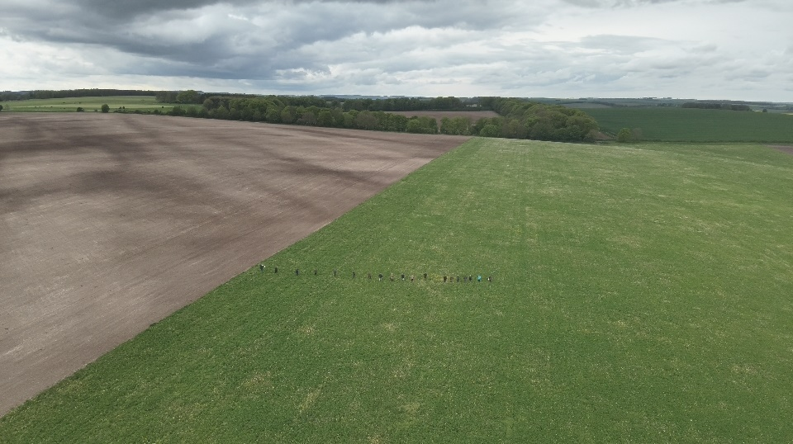
Fig 5: A large search-line in a relatively small plot of lucerne, close to the A303.

We do not have the resources for daily monitoring outside the nesting season. Financial support from Natural England has allowed at least weekly monitoring activities. As such, third party sightings from members of the public are very keenly received. Whilst our mature birds have an established pattern of movement between sites, we do see them move occasionally to outlying areas, whereas hand-reared juveniles have a particular tendency to roam. We aim to follow up all third party reports within 24 hours, before the trail goes cold.

The most valuable report we received this year was of a lone female on a Stone Curlew plot close to one of the original release points, which we were alerted to by the RSPB Stone Curlew monitoring team. Following up the report with a thermal drone survey enabled us to locate a nest, which prompted a conversation with the farmer and agreement not to cut the vegetation surrounding the plot. The nesting female has succesfully raised a chick from the nest, a great example of communication and cooperation leading to a positive result for the conservation of the species.

Geospatial Databasing

In 2024 with the support of the Wiltshire and Swindon Biological Record Centre (WSBRC), we created a database of sightings using the ArcGIS platform. GBG staff are undergoing training so that we can conduct our own analysis of sightings and nesting trends. We have cleaned and uploaded the last five years of sightings data to a database.

Field workers and drone teams are now equipped with dedicated tablets which can display all historical nests, sightings and field boundaries. This capacity is going to be particularly important where we have different teams searching on different days, allowing us to maintain a collective understanding and precisely target searching based on previous years’ finds.

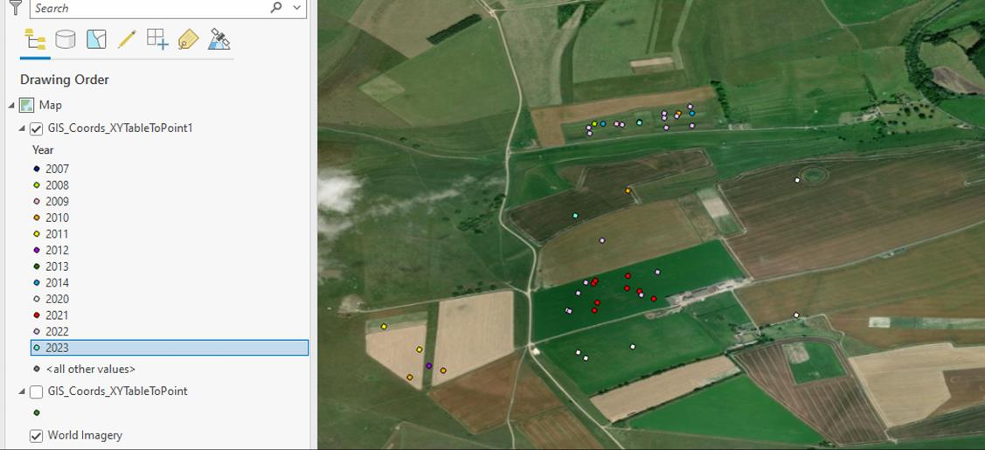
Fig 8: Nest locations recorded on the ArcGIS database.

We will continue to present our data to WSBRC on an annual basis, so that Bustard activity will be checked before land-use changes are approved. Our ongoing collaboration has greatly improved the presentation and our understanding of the birds’ behaviour, it will also mean the presence of Great Bustards will be flagged up when in any relevant planning applications.

WSBRC data also supports the Wilshire Local Nature Recovery Strategy (LNRS), which acknowledges the Great Bustard as a priority species.

2023-2024 Winter Census

Numbers of Bustards at their habitual overwintering sites fluctuate slightly, but regular counts in Winter 2023 were as follows:

Site | Male | Female | Total
Compton | 2 | 19 | 21
Southern sites | 11 | 8 | 19
South Western Site | 3 | 3 | 6
Oxfordshire |  | 1 | 1
Total | 16 | 31 | 47
Table 1: Winter counts across regular sites

Our winter counts demonstrate a similar movement pattern to previous years. Again, the core drove of females remained at Compton, whilst the male drove moved back to one of the Southern sites. Two males were left at Compton through the winter, comprising a blue ringed (2018) male and an unmarked, highly likely naturally reared male. We had several sightings of Black 17, one of our oldest wild females (2011) amongst the drove at Compton.

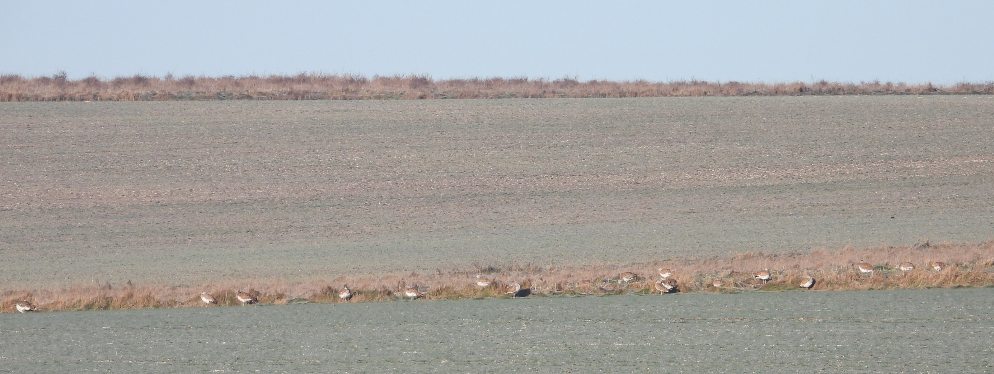
Fig 9:
This drove spent the majority of the winter grazing on the thin strip between two arable fields.

The male drove in the Southern area overwintered on oilseed rape. We observed Purple 5, our oldest wild bird, amongst this group. A female drove of 7-8 birds overwintered in the general area but shifted location several times. We lost contact with the drove in the South West, which is a small mixed-sex group. This group was eventually reported by a local gamekeeper in a field of oilseed rape a mile away on another farm, over the ridgeline and out of sight of its usual wintering location.
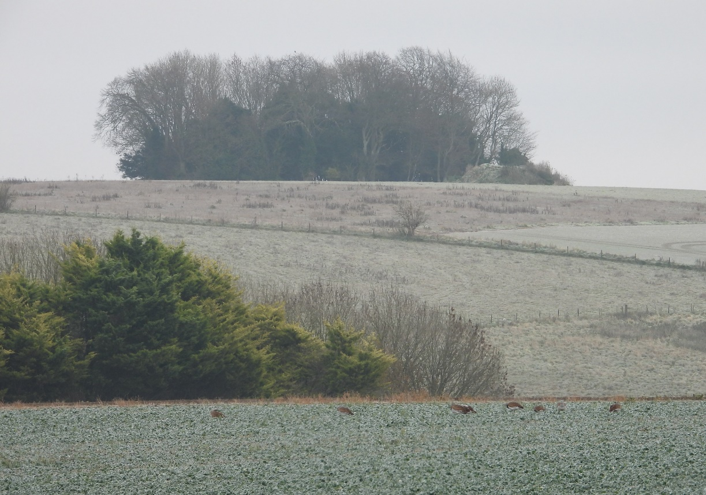
Only a single female was observed in Oxfordshire during the winter, although this is not a surprise as we know a second female had been lost as a result of a collision with a telegraph wire.
Fig 10: Female Great Bustards near one their favoured overwintering areas.

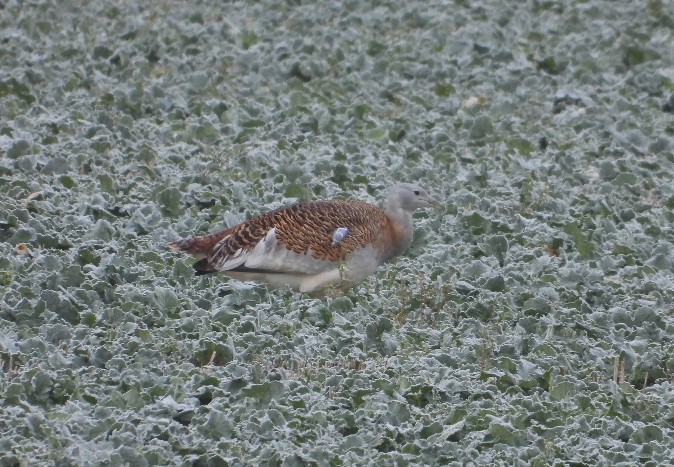
Fig 11: Purple 5, our oldest known surviving male, on oilseed rape during the winter.
He was released in 2007, having been hand reared by GBG in Russia.

The 2024 Lek

The male drove began the reconnaissance for females very early in comparison to previous years. Between Christmas and New Year’s Eve 2023 there were sightings of a very large group of Bustards, numbering 30-40, flying over the east of Salisbury Plain. We accept this sighting as credible, almost certainly representing the Compton and Southern droves combined. The males were also seen independently of the females on the Eastern edge of Salisbury Plain during this period. The males had settled properly back at Compton by February.

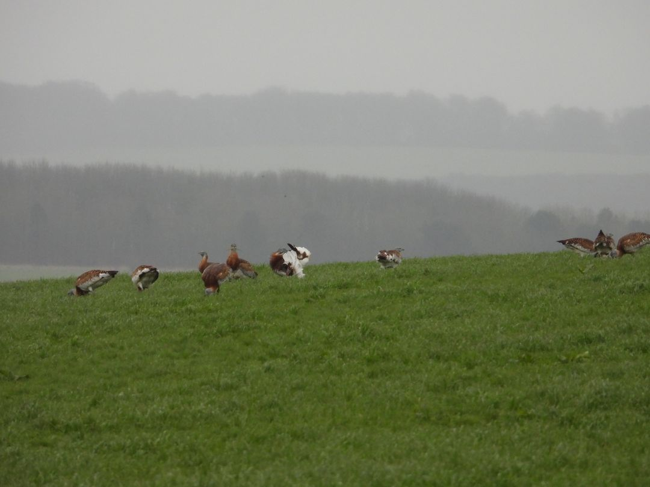
Fig12: Newly returned males at Compton in February 2024.

The first display of the year was observed at one of the Southern sites by a local farmer, although the lek proper did not begin until April. As of the third week in April, several females returned to their favoured nesting ground within the Reserve at Compton and by May the numbers of visible females began to drop as they vanished into cover to commence nesting.

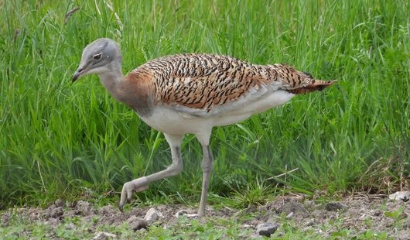
Fig 13: Red 75, a 2019 female hand-reared from an egg rescued from Spain.
She has spent much of her early life in Oxfordshire.

We observed a great deal more fighting between males this year, with some violent and long-lasting fights seen on the ridges around Compton. This is likely to have been two individual males competing with each other rather than an increasingly combative tendency amongst the wider group.

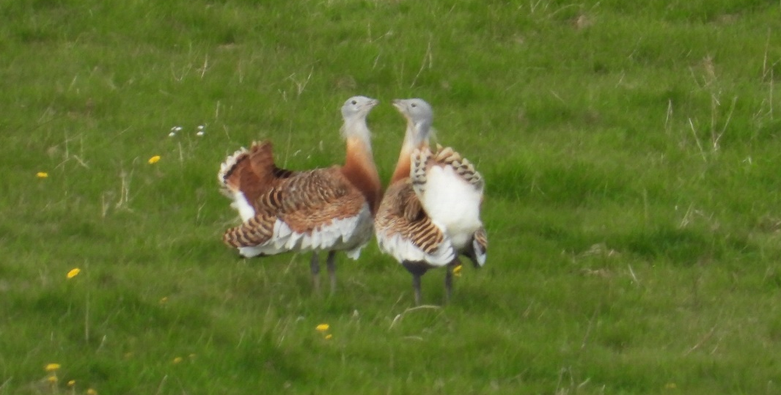
Fig 14: Competing males squaring up at Compton, April 2024.

Two males remained conspicuous throughout the Spring in the Stonehenge landscape, and we had occasional sightings of females there in early spring. Meanwhile at the Western site, the number of visible birds fell sharply, and two remaining males had disappeared by late Spring, suggesting an absence of females to display to, either because they were nesting or elsewhere.

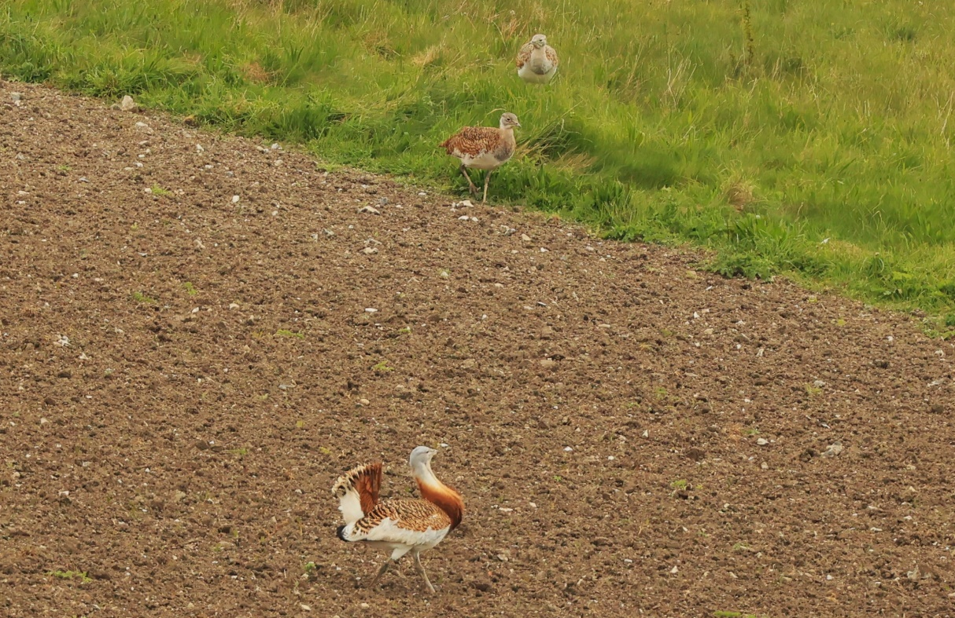
Fig 15: Females show interest in a male at Compton, April 2024.

Nesting

In 2024 46 nests were found, the highest annual total since the start of the project, the previous highest been 22 nests. This higher number is largely due to significantly improved monitoring rather than an increase in nests, it should also be noted the figure of 46 includes replacement clutches. 31 females were counted during winter 2023 of these we believe 27 of these would be of breeding age. It is also significant that we saw very few roaming females during May, suggesting that most of them were attempting to nest and that some of the roaming females we saw last year are now mature and nesting. We located the following number of nests:

Farm | Area | Number of Nests
Compton area | Reserve | 26
Compton area | Farmland | 4
Compton area | Top of Back of House
Compton area | Stone Curlew Plot | 1
Compton area | Mod Trg Area | 2
Southern Area | Farmland | 11
Southern Area | Conservation Plot | 1
Southwestern area | Farmland | 1
Total |  | 46

20 nests were judged as being under a high level of vulnerability, this assessment was based on silage cutting and within the Compton reserve a high nesting density, known to lead to infanticide. Eggs from these nests were recovered under a Natural England licence. This marks a change from our approach in previous years, where we have attempted to preserve nests in situ, noting that since using the drone we have identified far more nests. In silage crops in situ preservation, requires an unmown plot of at least 2 hectares (less than this typically leads to abandonment), difficulties arise when the second silage cut is taken and chicks could be widely roaming, not confined to the previously unmown plot.

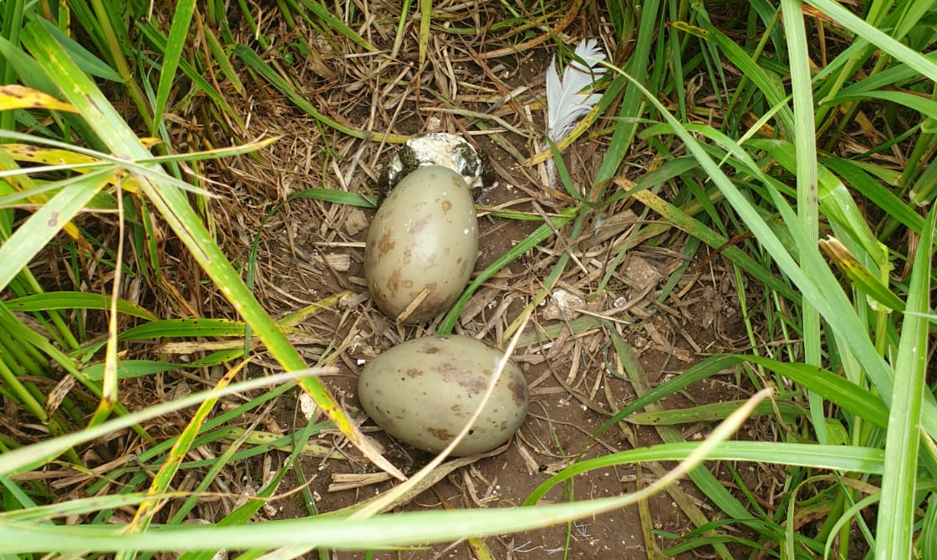
Fig 16: Eggs found in rye grass in the Stonehenge landscape.

26 nests were not disturbed and left for natural incubation (including second or even third clutches). At time of writing, we have only identified two fledged juveniles as a result of natural rearing in 2024, one in the south, and one at Compton.

The number of nests according to habitat type is as follows:

Habitat Type | Number of Nests
Managed Habitat (conservation plots) | 30
Grassland (training area, low intensity grazing) | 2
Lucerne | 8
Rye Grass | 2
Herbal Ley | 2
Wheat | 1
Oats | 1
Total | 46

Although this could be seen as a marked preference for conservation plots, this is more a reflection of site fidelity, representing what is growing in vicinity of the release sites. Nesting typically occurs in close proximity to release points, 34 of the 46 nests discovered were within a kilometre of a release point, 30 of these within 500m of a release point.

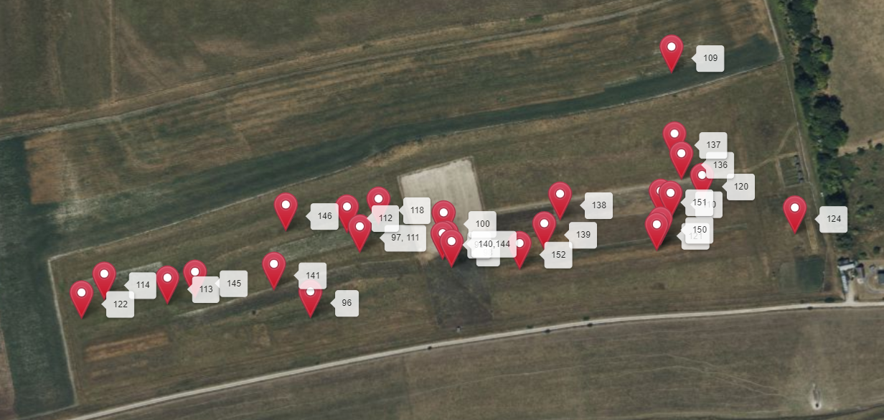
Fig 17: Nest locations on the reserve at Compton in 2024

Nests by distance from nearest release point

Distance from nearest release point | 0-500m | 500m-1km | 1-2km | 2-3km | 3-4km | 4-5km
Number of nests found | 30 | 4 | 7 | - | 4 | 1
% of nests found | 65% | 9% | 15% | - | 9% | 2%

We only have a limited body of evidence with which we can understand nest failure, this is an aspect which we hope to better understand in coming years. We saw three instances of females killing other females’ chicks within the reserve, this was also observed on three occasions in 2023. The fact we saw this behaviour on three separate occasions, during limited periods of observation indicates this is a far more frequent occurrence. It seems likely that the density of females nesting within a small section of the reserve is causing this issue. We have undertaken not to release any more birds into the reserve for the foreseeable future. Elsewhere we know that one nest was abandoned on private farmland due to disturbance by a dog walker, one due to silage cutting and at a separate location an (infertile) egg was found which appears to have been predated and dropped.

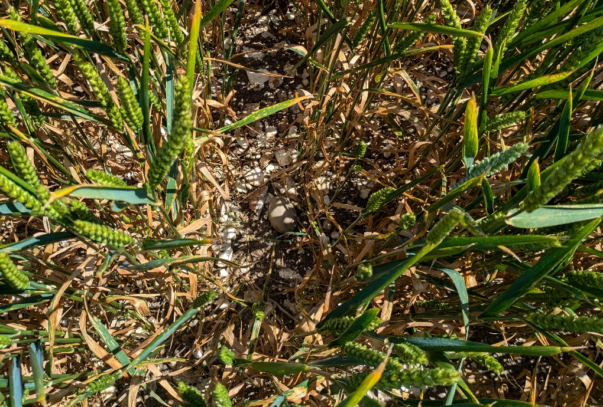
Fig 18: Spot the egg! An abandoned nest.
The nest is likely to have been abandoned due to dog walking disturbance.

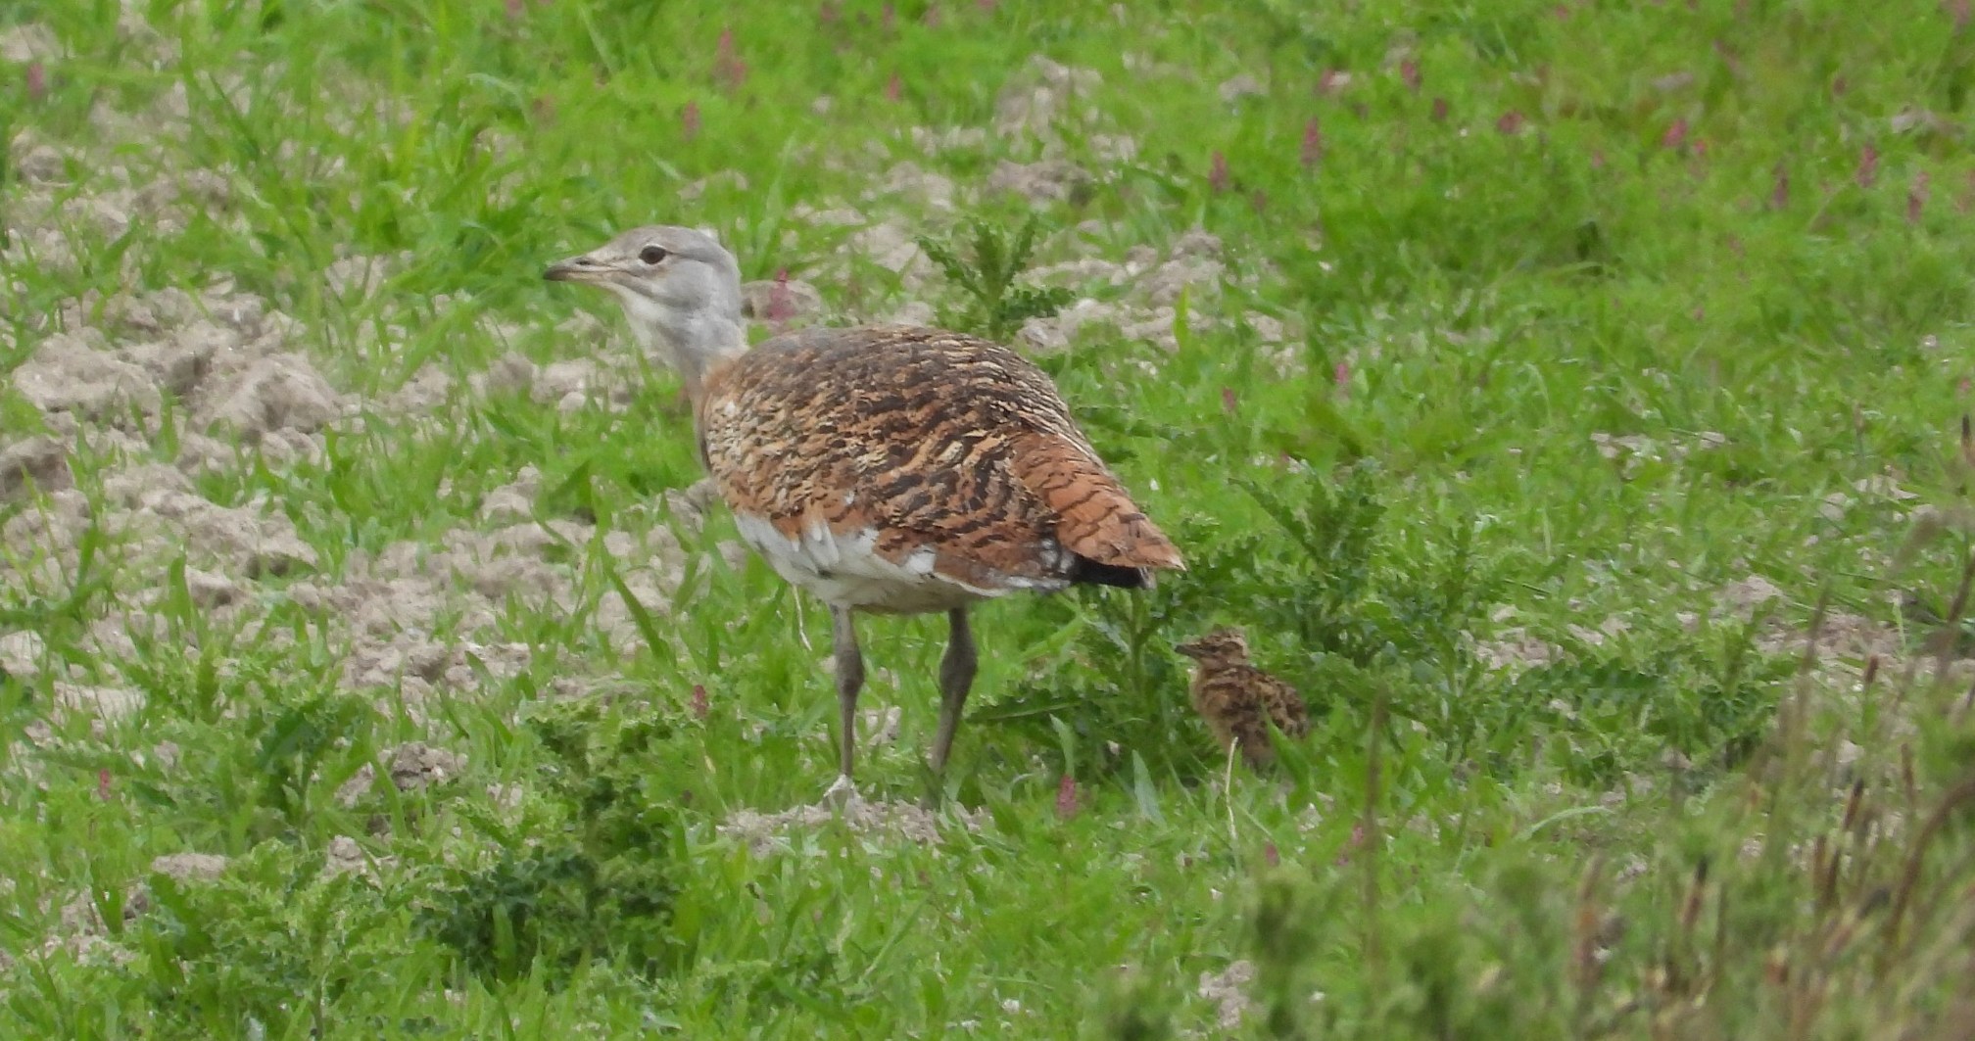
Fig 19: Mother and chick within the Reserve at Compton

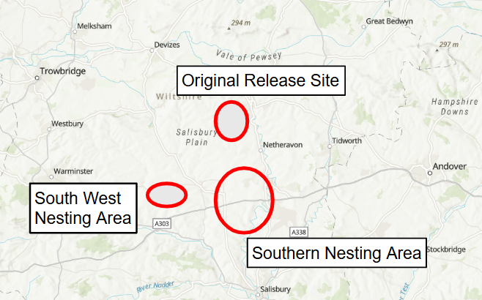
Fig 20: Distribution of nests in 2024

Return to Winter Habitat

Following dispersal for breeding and nesting in the Spring, the birds regrouped during the Summer. Their subsequent movements were slightly different to 2023. The males ultimately returned to wintering fields in the late Summer, but did not spend time in the impact area in the intervening period. Around 5-7 females also left Compton for the wintering fields, which is quite different to previous years when they have remained. They joined the resident females at this location, forming a much larger drove at this location than we have seen previously. We suspect that the abundance of oil seed rape in this area may be a factor. Mature birds reappeared at a western site, although we are uncertain where they spent the Spring. It is feasible that they had joined the lek at Compton.

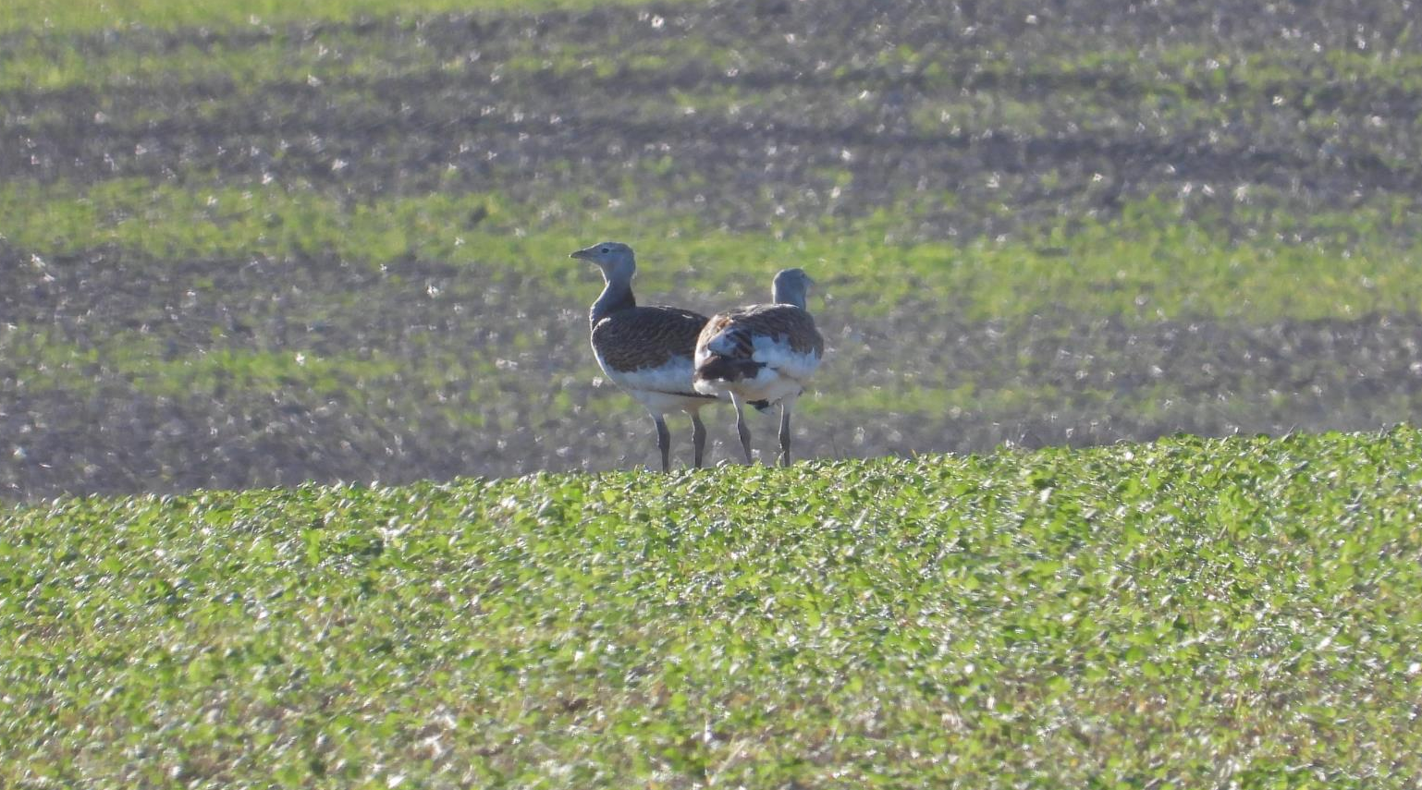
Fig 21: Two Bustards at a southern site, assessed to be a mother and juvenile male.

Head Starting

We rescued eggs from 20 vulnerable nests. The retrieved eggs were transferred immediately after recovery, in travel incubators, to Cotswold Wildlife Park for incubation. Two chicks hatched with splayed legs, and the remaining 27 healthy chicks which were all reared successfully at the GBG facilities, and subsequently released onto the margins of Salisbury Plain.

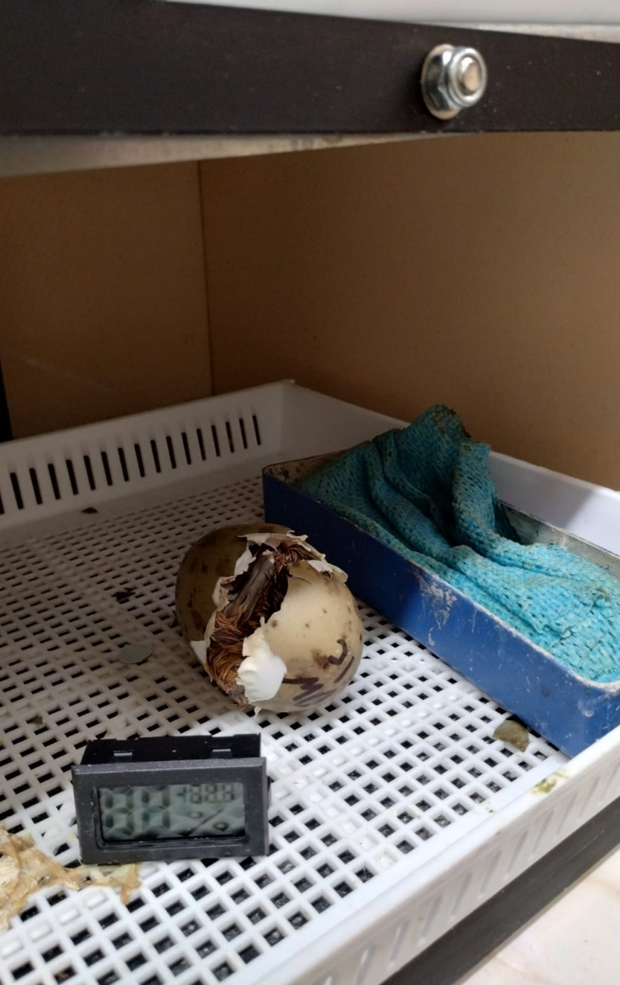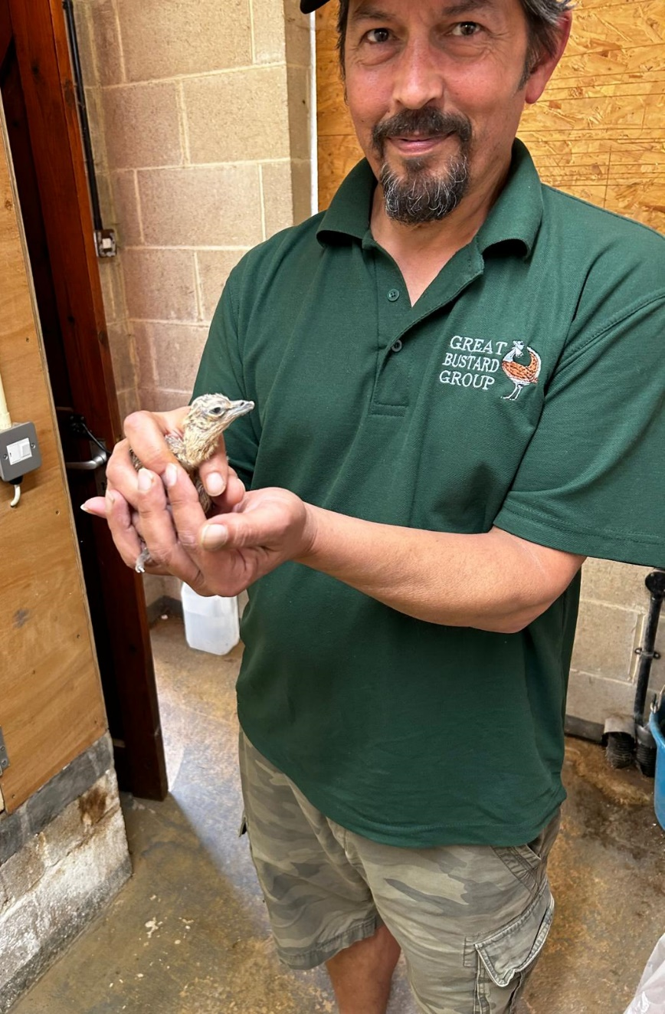
Fig 22: A rescued egg with resultant chick

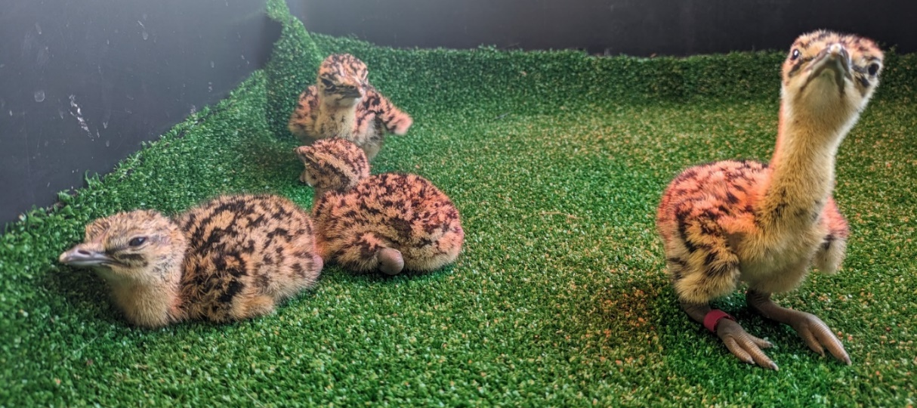
Fig 23: Two-day old chicks at Compton.

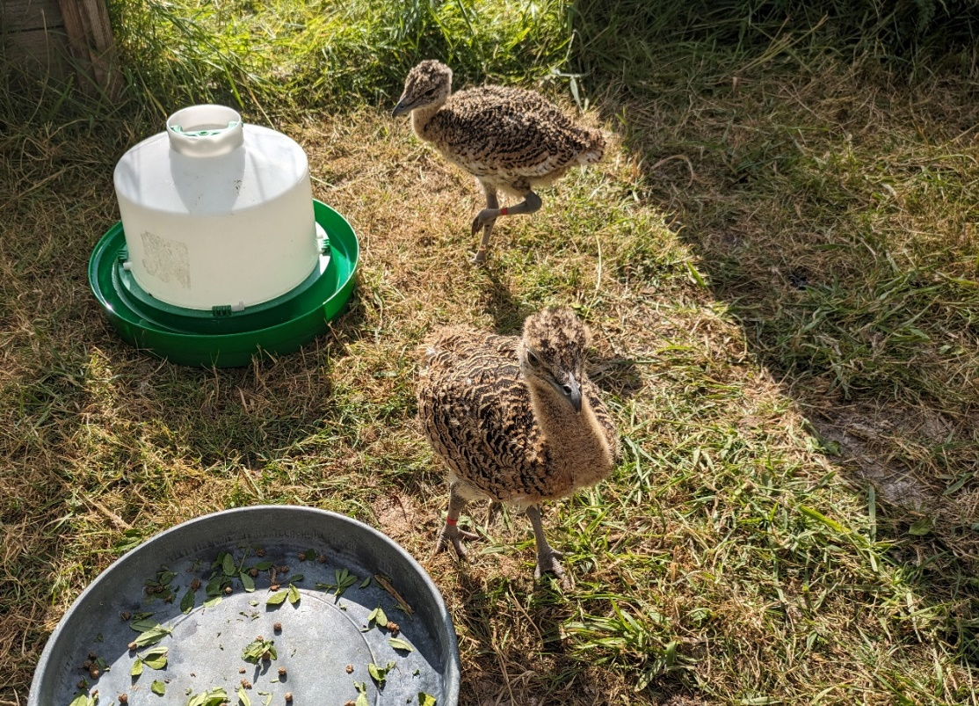
Fig 24: These chicks have been moved to an outside pen.
They are feeding from a mix of lucerne, insects and Lundi bird feed.

GBG recognises low productivity at the Compton reserve, this has been caused by releasing a high number of birds in the same area, in light of this no further releases took place in the reserve. 17 birds were released at a new location, slightly West of the existing populations. This site is an arable farm, surrounded by the grasslands of the MOD estate on Salisbury Plain. 10 birds were released at a South Western site to strengthen the small population there. 7 of the released females were fitted with trackers.

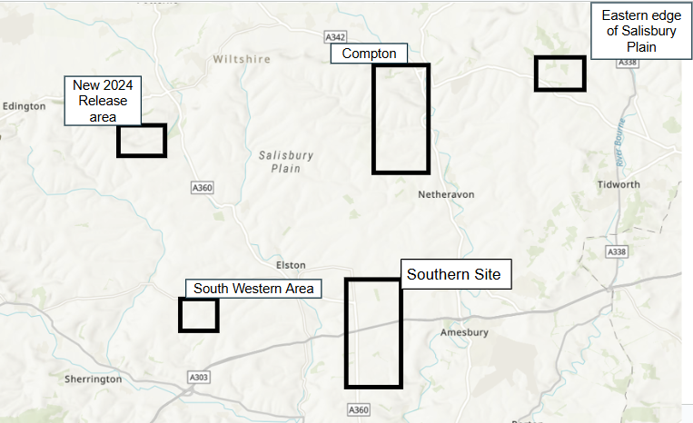
Fig 25: Resident or seasonal distribution of Great Bustards in 2024

We were able to identify behaviour patterns amongst the tracked birds, such as spending their day on a conservation plot in the longer grass, then moving onto the shorter chalk grassland at night to avoid predators. Upon release we found most juveniles remained very close to their release area for the first few weeks, however a few immediately went in search of other Great Bustards - with one traveling from the south western site to the Stonehenge landscape within 48 hours of release, and one released in the western area heading to the south western group. . By October we saw one tracked bird fly down to Axmouth, Devon. The tracker capabilities saw us receiving information several times a day, as well as the location, we could determine flying altitude and length times, they showed us how on longer flights Great Bustards may follow the contours of the land, and enabled us to see their use of habitat.

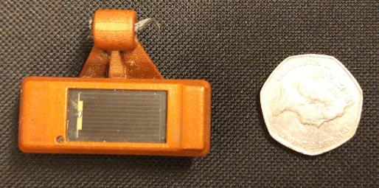
Fig 26: A solar powered Ornitela GPS tracker.
We fitted these to a small number of females released in September 2024.

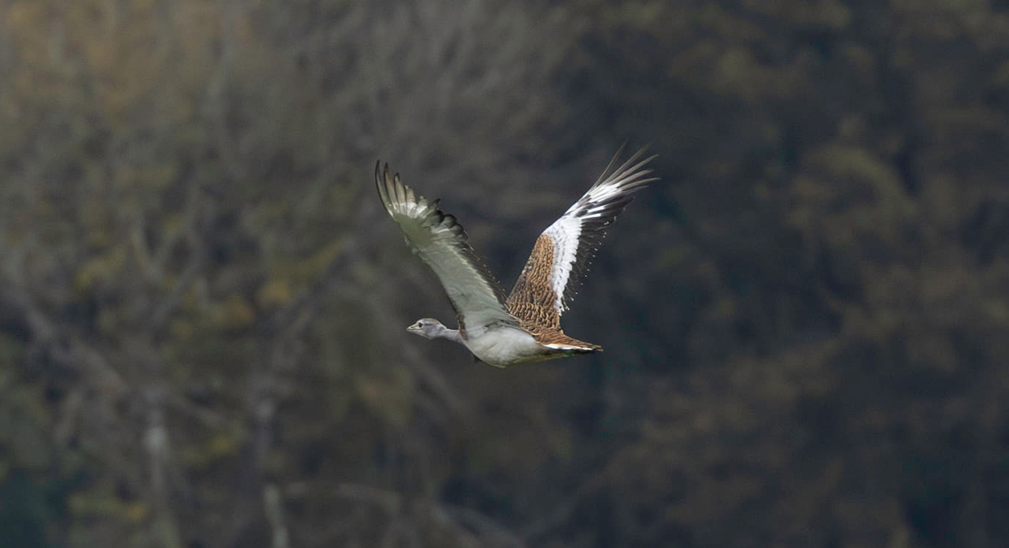
Fig 27: Green 33 who ventured to Devon during dispersal.

One tracker fell off at the time of release. Of the remaining 6 tracked birds, 1 died after a powerline collision, fox predation occurred on 3 occasions and 2 died of unknown causes, whilst the trackers were only active for a few months, they have provided GBG with new and valuable information, giving us a better understanding of behaviour upon release. We have been able to retrieve 5 of the 7 trackers, which we will deploy again next year.
We have had numerous reports of juveniles around Wiltshire since release, but location of the majority of the head started birds is currently unknown.
This is the first time we have used tracking technology in at least a decade, and initial results are promising. If our tracked females survive long enough to mature and commence nesting, the use of trackers will be invaluable in locating their nest sites. Otherwise, we can also gain valuable information about causes of mortality, noting that the activity of hand reared juveniles tends to be different from that of naturally reared birds.

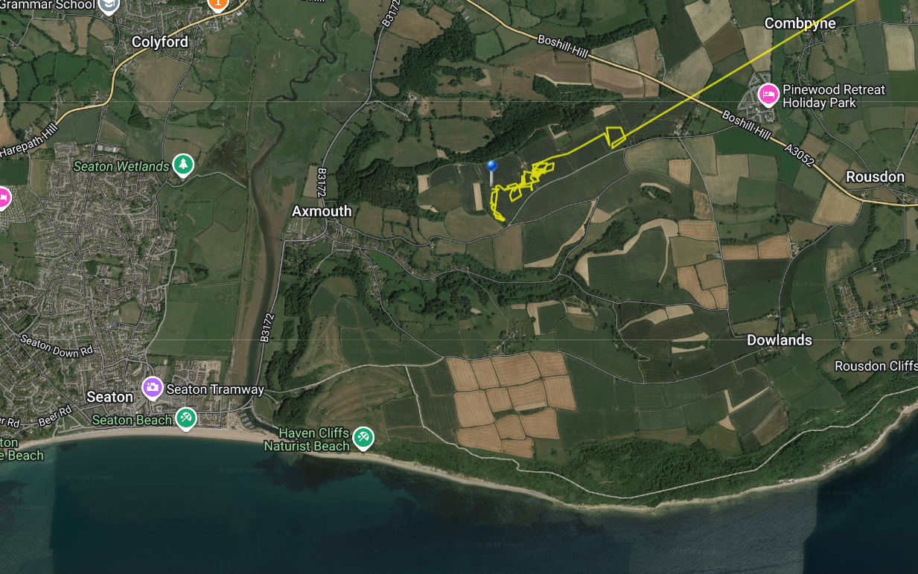
Fig 28: Tracking report from Green 33, visiting Devon from Salisbury Plain.

Conclusion

The survival rate of mature birds remains high at over 90%. Natural recruitment is low. Of the 31 females, 11 nested in the reserve with an identified problem of infanticide caused by high nesting density, of the remaining 20 females, at least 3 are sexually immature, leaving 17 other mature females. These 17 females recruited a minimum of 2 chicks, 0.2 chicks per mature female is considered the minimum recruitment required for sustainability, our females would need to have produced 3 chicks to meet this figure.

With the head started birds the UK Great Bustard population has increased in 2024. The success of the head starting will begin to become apparent in the Spring and Summer of 2025.

The number of nests discovered is the highest since the project began, although we estimate that up to a third of these finds represent replacement clutches following nest failure. This higher total represents not just greater competence with drone planning and survey, but also represents a higher actual number of females nesting. We assess we have found around 80-90% of our nesting females this year. Each nest found allows us to make a decision on whether to intervene or leave the bird in-situ, according to individual farmers plans for the fields in which the birds are nesting.

Other than the observed incidents of infanticide in the reserve the reasons for breeding failure are not known. The species is a notoriously difficult one to observe and while acknowledging this, extra resources and new techniques will be used in 2025 to try and address this gap in our knowledge.

We have released Bustards in a new area in order to create a wider spread of nesting, building on our assessment that the density of nesting females is limiting productivity on the reserve.
We have two core challenges to face for future nesting seasons, firstly ensuring that chicks can survive to the point of fledging, and secondly resourcing our conservation work, comprising monitoring, rearing and habitat improvement.

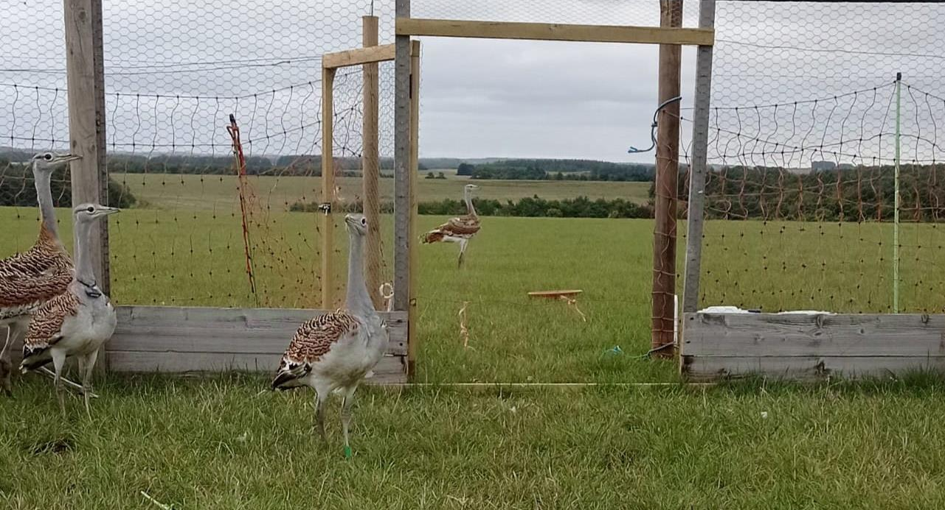
Fig 29: Hand reared juveniles cautiously exploring beyond their release pen, September 2024.
The female second from left has a necklace tracker.

Future Conservation Plans

Increased monitoring has helped identify and clarify the reasons for low productivity in one sub population but has also confirmed greater monitoring efforts are required. Dedicated monitoring of nests and natural chick rearing is a priority.

An error of creating too a high nesting density has been identified. These high density nests provide a source of vulnerable eggs, lending themselves to head starting. The releases will take place in new areas or areas with a low nesting density. These new sites will be within typical seasonal range of the species of up to 6 miles. Newly released birds from sites close to established groups will benefit from being able to join wintering droves and established leks.
Of the known causes of mortality for the head started birds, the leading reason is predation by fox. Fox control at release sites will be increased during the relevant period – typically to cover a month post release. The high nest site fidelity gives a high degree of nesting predictability and GBG will continue to increase the provision of safe and managed habitat.

2024 has seen the Great Bustard elevated from a poorly defined (not normally native) species to a critical species for the Wiltshire LNRS and to a national medium priority species by Natural England. It is hoped and anticipated that both these designations will significantly increase the practical help given to improve the status of the Great Bustard in the UK and lead to other organisations working to benefit the species. This is of particular importance and relevance as 2024 also saw the IUCN and bird life classification moved from vulnerable to globally threatened.

Thanks and Acknowledgements

The Great Bustard Group is always indebted to its volunteers who undertake tasks ranging from nest searching to fundraising to rearing chicks. Particular assistance has come from the Cranbourne Chase National Landscape and the North Wessex Downs National Landscape who have provided a second drone and funding for ArcGIS training. Natural England funded the purchase of the trackers and further dedicated funding for monitoring. Jon Isherwood (WSBRC) for his valuable assistance in digitising records and training of GBG staff. Cotswold Wildlife park for their assistance with incubation. The GBG expresses its ongoing gratitude to all its members, supporters and the individuals and charitable trusts and foundations who have made the project possible through their generosity.







